Test Case: tc006_SPX_Dev5_Crear_Requisicion_Spot_Tipo_Cobro_Proyect_Urgent
Step 1 - Enter username and password and click to button Enter: Credentials Entered
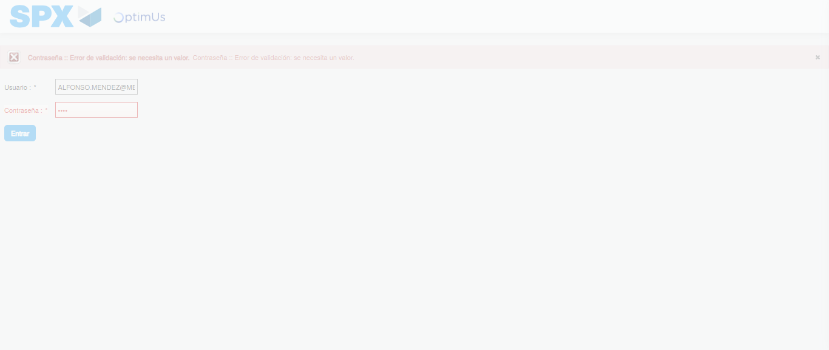Image file-name: QC_Testing-tc006_SPX_Dev5_Crear_Requisicion_Spot_Tipo_Cobro_Proyect_Urgent-1783361964081

Step 2 - Select to UEN and Access to Spot Buy Requisitions : UEN Correctly selected and Correct access
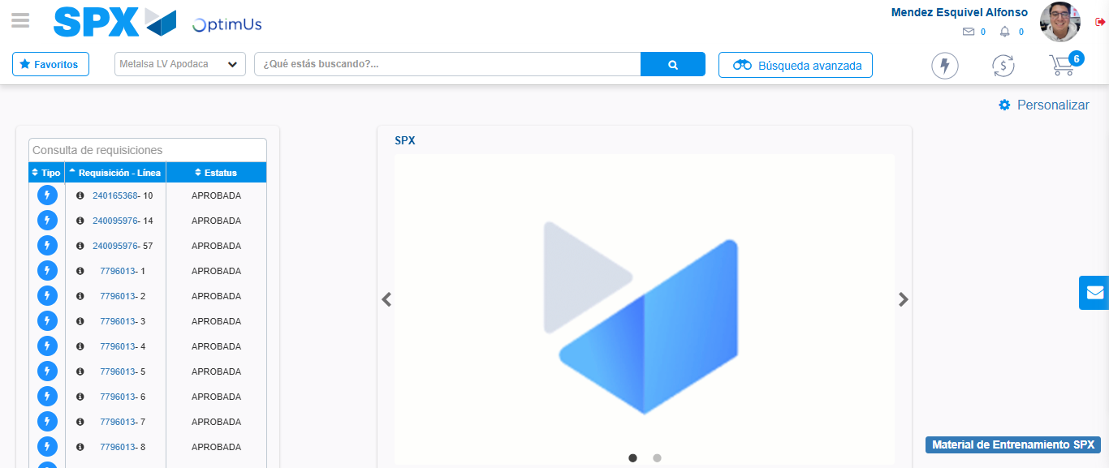Image file-name: QC_Testing-tc006_SPX_Dev5_Crear_Requisicion_Spot_Tipo_Cobro_Proyect_Urgent-1783361990472

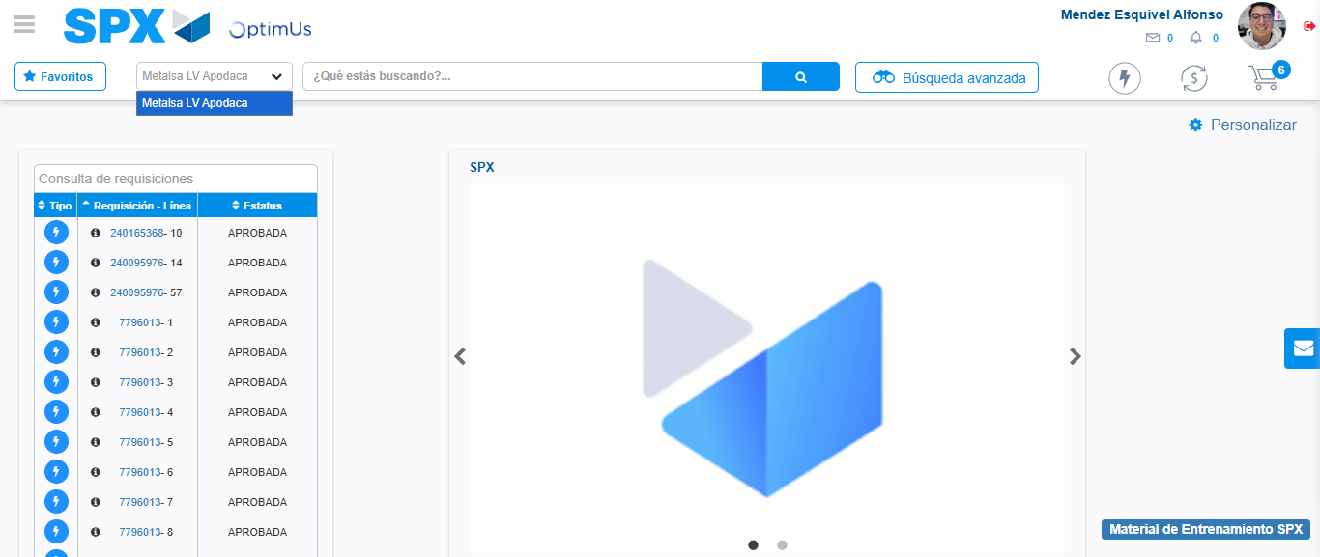Image file-name: QC_Testing-tc006_SPX_Dev5_Crear_Requisicion_Spot_Tipo_Cobro_Proyect_Urgent-1783361993067

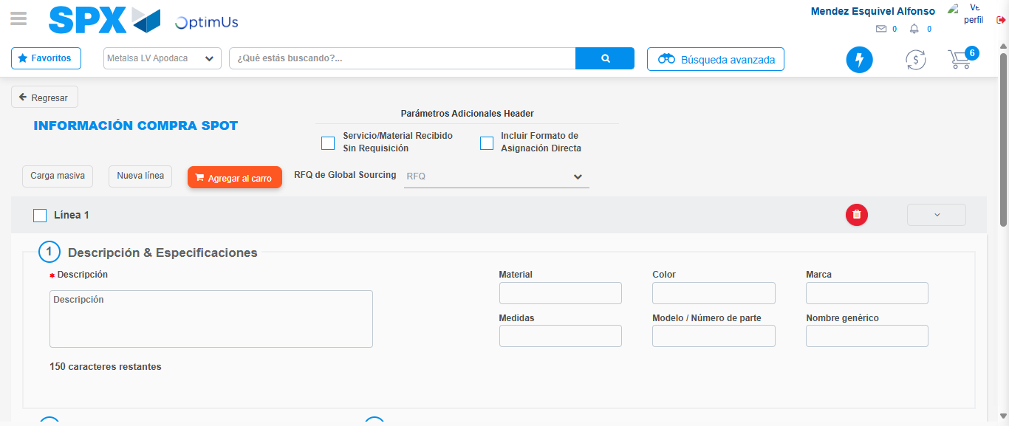Image file-name: QC_Testing-tc006_SPX_Dev5_Crear_Requisicion_Spot_Tipo_Cobro_Proyect_Urgent-1783362026462

Step 3 - Data Capture Spot Buy Requisition: Data captured correctly
Image file-name: QC_Testing-tc006_SPX_Dev5_Crear_Requisicion_Spot_Tipo_Cobro_Proyect_Urgent-1783362026726

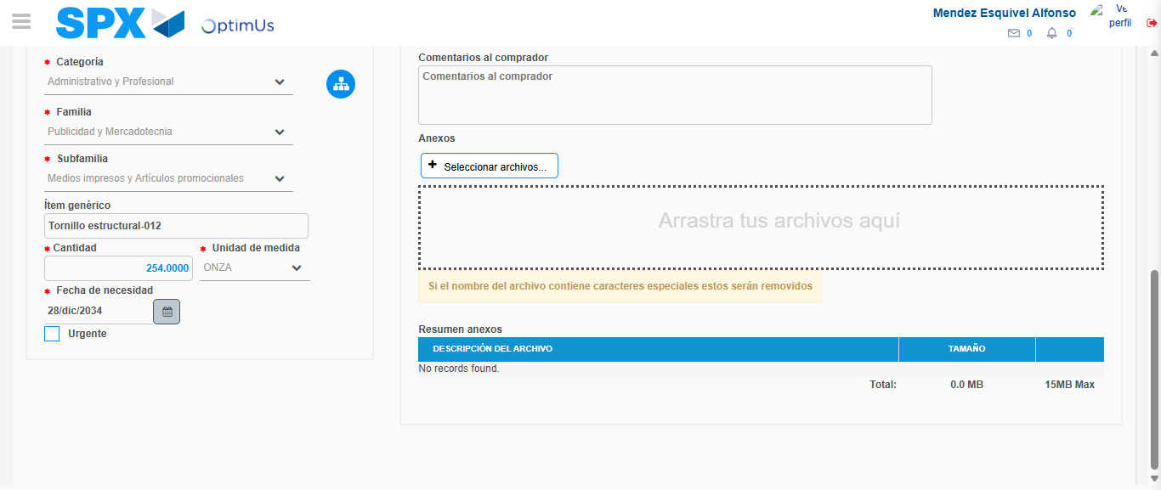Image file-name: QC_Testing-tc006_SPX_Dev5_Crear_Requisicion_Spot_Tipo_Cobro_Proyect_Urgent-1783362039801

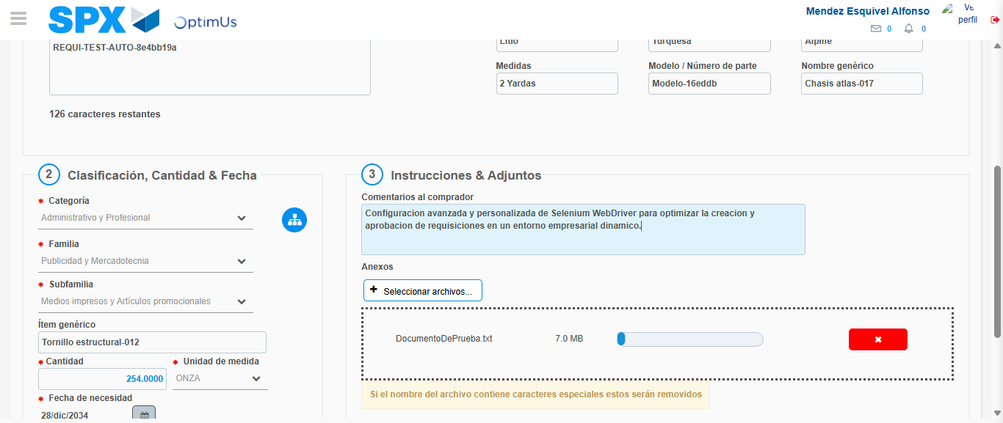Image file-name: QC_Testing-tc006_SPX_Dev5_Crear_Requisicion_Spot_Tipo_Cobro_Proyect_Urgent-1783362040726

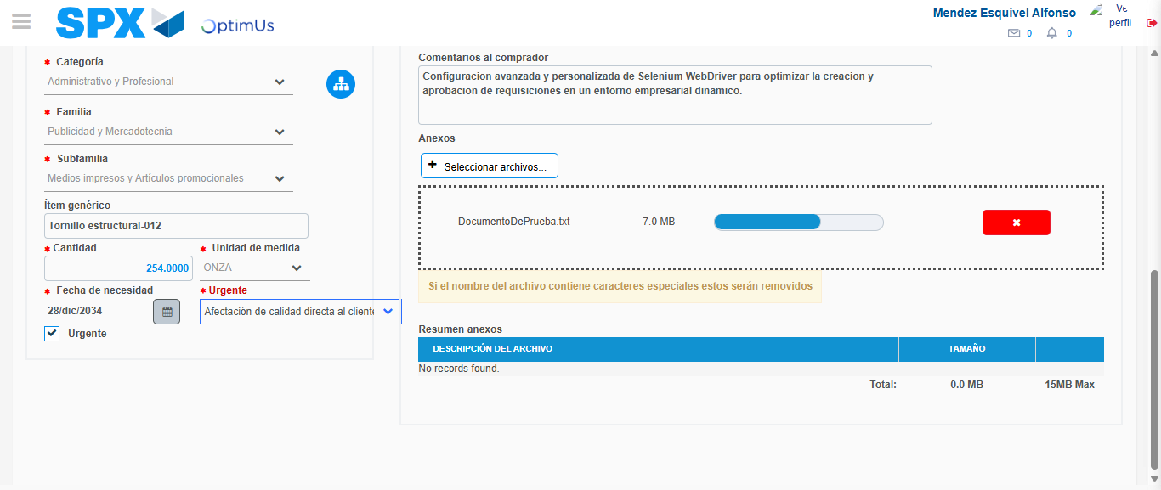Image file-name: QC_Testing-tc006_SPX_Dev5_Crear_Requisicion_Spot_Tipo_Cobro_Proyect_Urgent-1783362044652

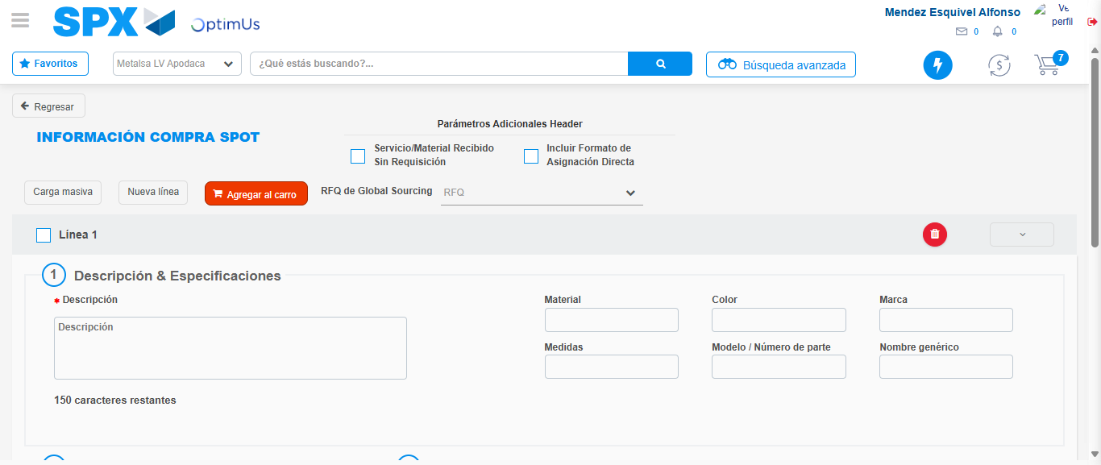Image file-name: QC_Testing-tc006_SPX_Dev5_Crear_Requisicion_Spot_Tipo_Cobro_Proyect_Urgent-1783362050977

Step 7 - Return to Main Page SPX : Return to Main Page SPX
Image file-name: QC_Testing-tc006_SPX_Dev5_Crear_Requisicion_Spot_Tipo_Cobro_Proyect_Urgent-1783361990472

Image file-name: QC_Testing-tc006_SPX_Dev5_Crear_Requisicion_Spot_Tipo_Cobro_Proyect_Urgent-1783361993067

Image file-name: QC_Testing-tc006_SPX_Dev5_Crear_Requisicion_Spot_Tipo_Cobro_Proyect_Urgent-1783362026462

Image file-name: QC_Testing-tc006_SPX_Dev5_Crear_Requisicion_Spot_Tipo_Cobro_Proyect_Urgent-1783362053265

Image file-name: QC_Testing-tc006_SPX_Dev5_Crear_Requisicion_Spot_Tipo_Cobro_Proyect_Urgent-1783362053498

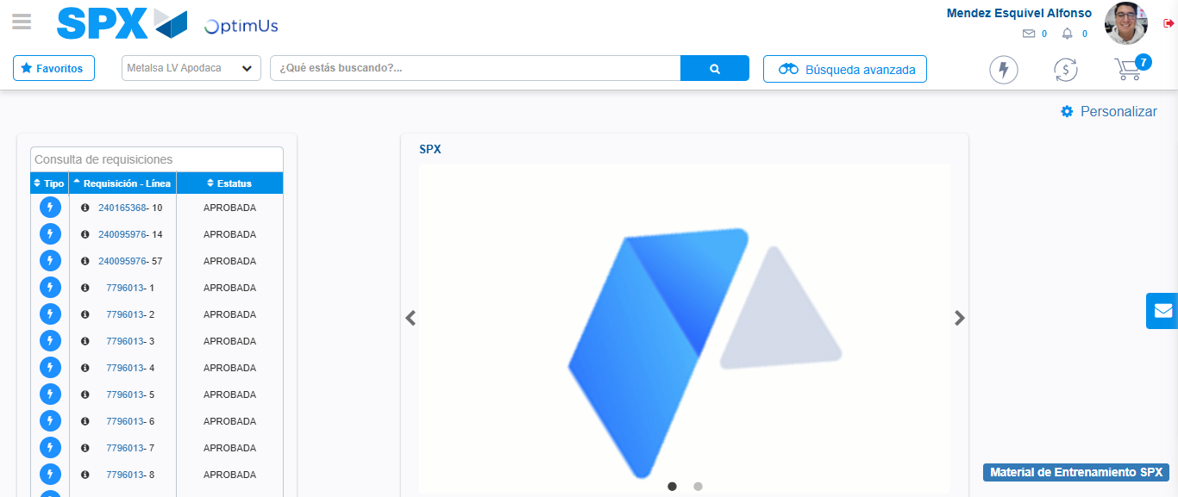Image file-name: QC_Testing-tc006_SPX_Dev5_Crear_Requisicion_Spot_Tipo_Cobro_Proyect_Urgent-1783362074712

Step 8 - Log Out : Log Out SPX
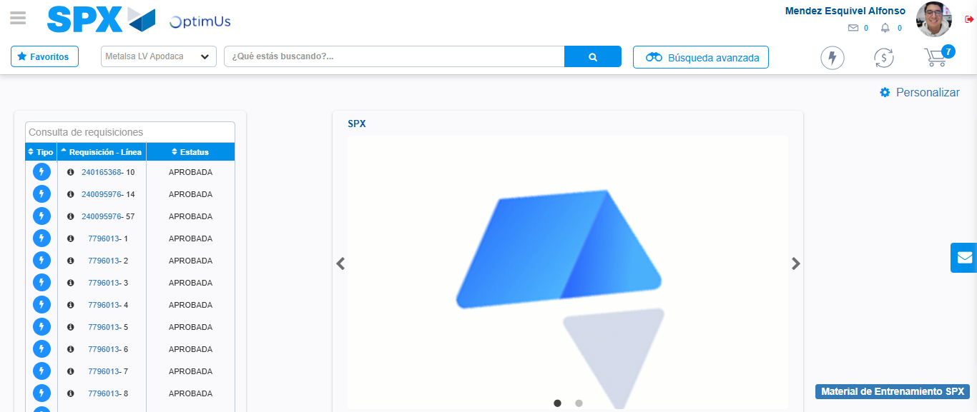Image file-name: QC_Testing-tc006_SPX_Dev5_Crear_Requisicion_Spot_Tipo_Cobro_Proyect_Urgent-1783362075053

